Project Design Phase-II
Technology Stack (Architecture & Stack)

Date | 27 September 2026
Team ID | SWTID-2026-4039
Project Name | AI Weather Wise
Maximum Marks | 4 Marks

Technical Architecture:
The Deliverable shall include the architectural diagram as below and the information as per the table1 & table 2

Example: Order processing during pandemics for offline mode

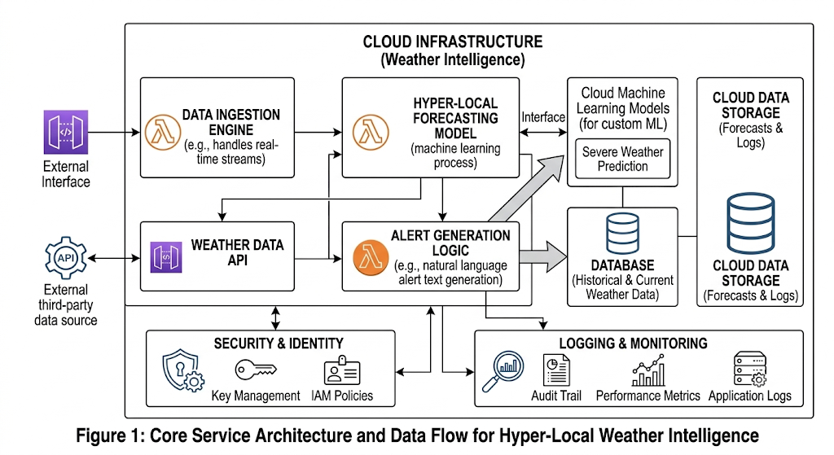

Table-1 : Components & Technologies:
S.No | Component | Description | Technology
 | User Interface | Frontend interface for users to view hyper-local weather forecasts, severe weather alerts, and AI summaries. | HTML, CSS, JavaScript, React.js
 | Application Logic-1 | Core backend server logic, routing, user authentication, and data orchestration. | Node.js / Express.js (or Python)
 | Application Logic-2 | AI-driven weather text analysis and natural language alert summary generation engine. | Gemini API / IBM Watson Natural Language Understanding
 | Application Logic-3 | Voice-assisted weather query and automated interactive user support engine. | IBM Watson Speech to Text / Assistant
 | Database | Persistent storage for user profiles, saved favorite locations, and application configurations. | MongoDB (NoSQL)
 | Cloud Database | Managed cloud database hosting historical weather data logs, user alert history, and forecast cache. | MongoDB Atlas / IBM Cloudant
 | File Storage | Cloud file storage for model artifacts, generated PDF weather reports, and system log backups. | IBM Cloud Object Storage / AWS S3
 | External API-1 | Primary external data source for real-time weather, radar metrics, and satellite data feeds. | OpenWeatherMap API / IBM Weather API
 | External API-2 | Secondary external service for user identity verification and location-based profile mapping. | Government Location API / Secure Identity Verification API
 | Machine Learning Model | Custom ML model for hyper-local microclimate prediction and severe storm probability scoring. | Python, TensorFlow / Scikit-Learn
 | Infrastructure (Server / Cloud) | Deployment platform for hosting microservices, backend APIs, and ML prediction pipelines. | Local: Node.js Environment  Cloud: Docker, Kubernetes / IBM Cloud Foundry / AWS Lambda  .

Table-2: Application Characteristics:
S.No | Characteristics | Description | Technology
 | Open-Source Frameworks | Utilizes robust open-source web frameworks, database ORM, and ML libraries for efficient rapid development and community-supported reliability. | Express.js, React.js, Mongoose, TensorFlow / Scikit-Learn
 | Security Implementations | Employs end-to-end data encryption, token-based authentication, strict API rate limiting, and standard OWASP security headers to prevent unauthorized access and attacks. . | JSON Web Tokens (JWT), Bcrypt, HTTPS / TLS 1.3, Helmet.js, IAM Controls
 | Scalable Architecture | Designed using a microservices-oriented, decoupled 3-tier architecture to scale computing resources, ML inferences, and API endpoints independently as traffic grows. | Docker, Kubernetes, AWS Lambda / Cloud Foundry, Node.js
 | Availability | Guarantees high availability and zero downtime through load balancing, automated health checks, multi-region database replication, and failover management. | NGINX Load Balancers, MongoDB Atlas Replica Sets, Cloud Health Checkers
 | Performance | Optimized for high throughput and low-latency responses by caching frequent weather API calls, serving UI assets via CDN, and utilizing asynchronous non-blocking I/O. . | Redis Cache, Cloudflare CDN, Node.js Async Workflows

